**Exercise**

Q1. - Write a program to display values of enums using a constructor & getPrice() method (Example display house & their prices).

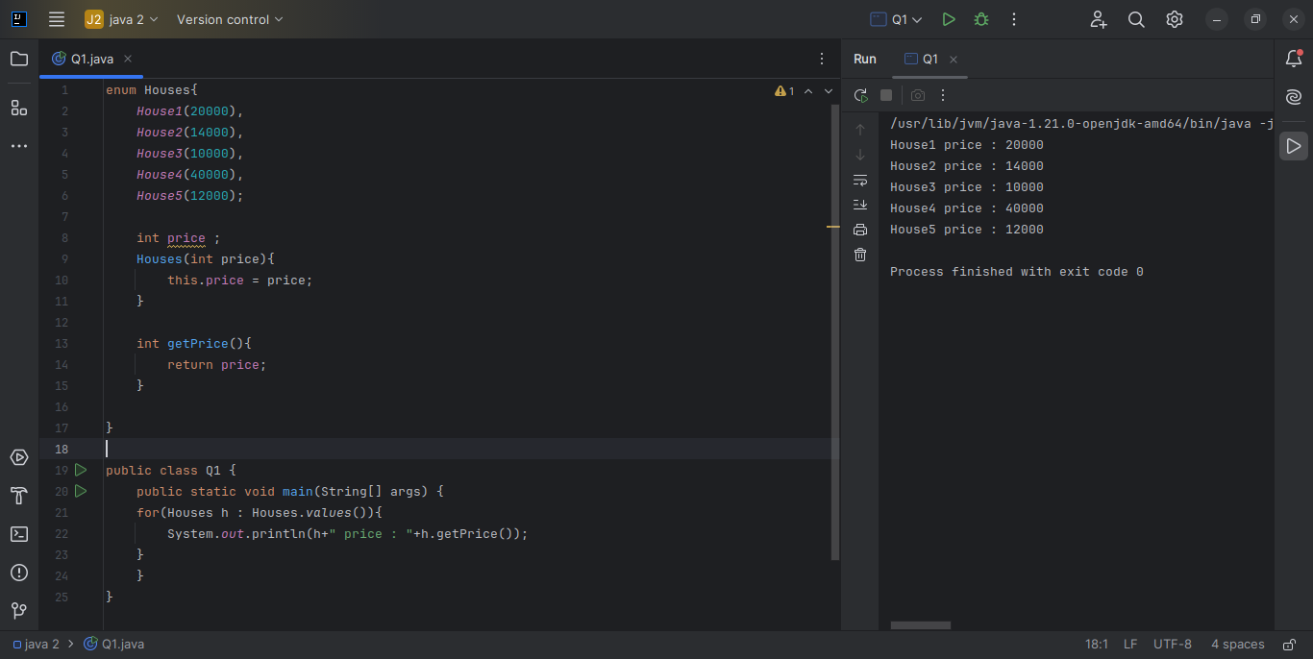

Q2. - Create a User class with fields: firstname, lastname, age, phonenumber. Write a program which accepts values of user fields from commandline, create object and append that to a text file. After every user creation the program should prompt: "Do you want to continue creating users? (Type QUIT to exit)" and keep on accepting values and writing to file unitl user quits.

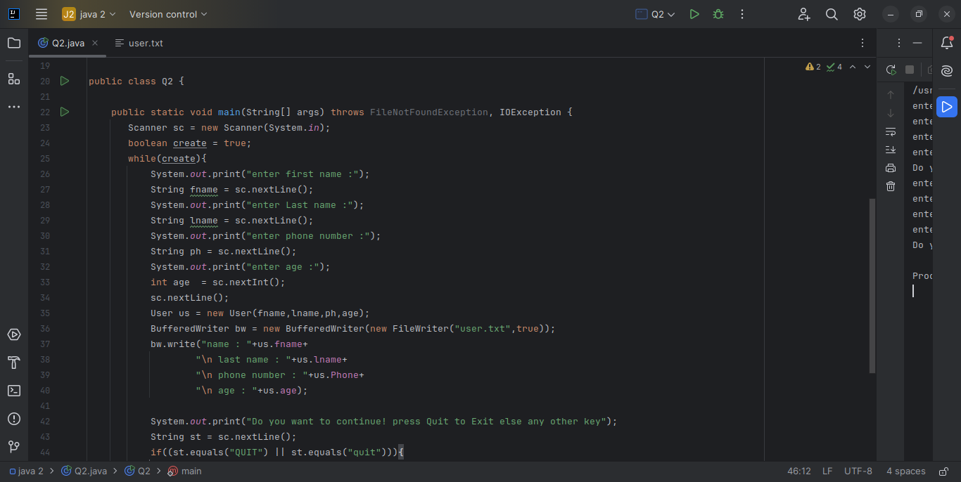

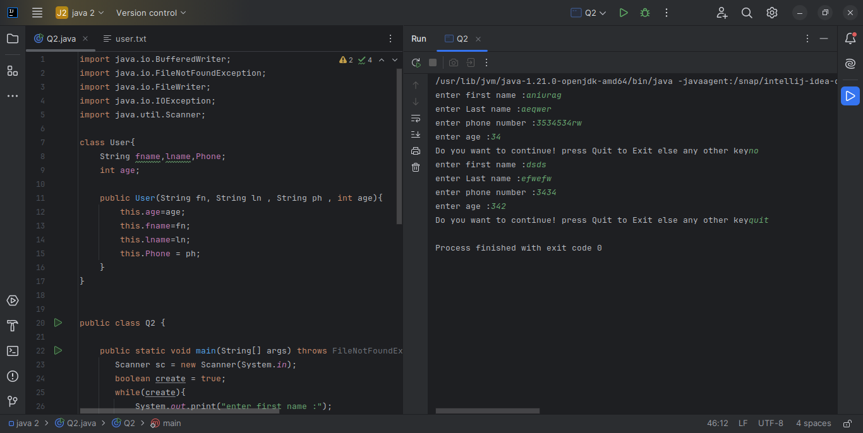

Q3. - Write a program to count number of occurrences of a word in a file. The file name and word should be supplied through commandline.

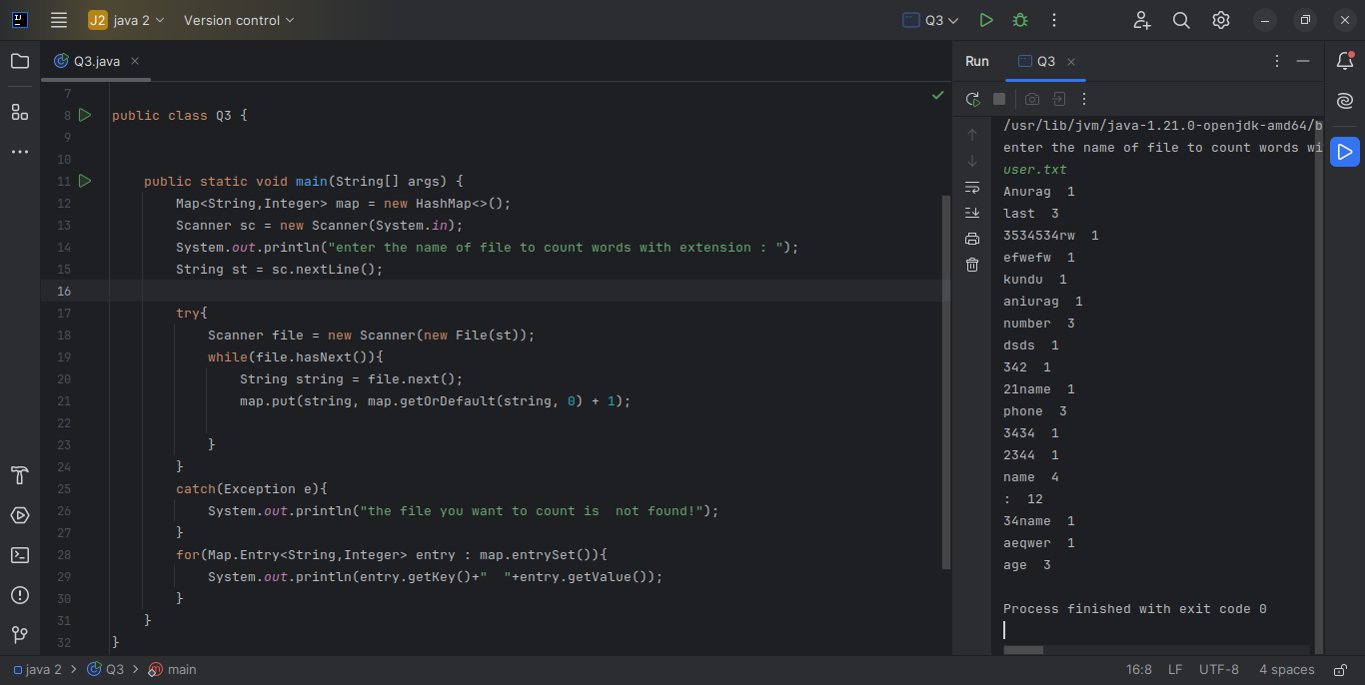

Q4. - Write a program to show application of Factory Design Pattern.

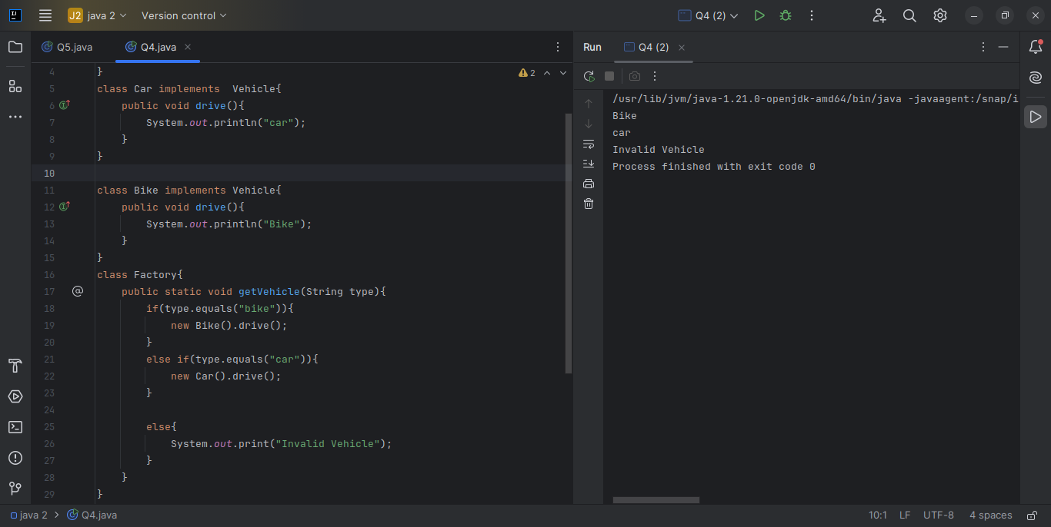

Q5. - Write a program to show application of Singleton Design Pattern.

